SC2107 Lab4 Assignment Sheet (to be submitted to NTULearn before next lab)

Name: ___Ganesh Rudra Prasadh___ Lab Group: SCE1 Date: 15/Nov/2023___

1. Section 6.1. What is the issue when an obstacle is placed too close to the IR sensor? What can you do to prevent such ambiguity?

Answer: 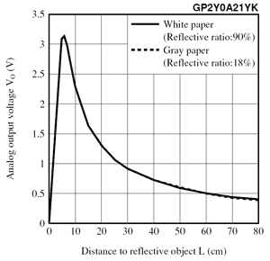

Note that this is the graph of an IR sensor. If the object is too close to the sensor, the reading would be the same as the reading from a larger distance (some intersection). This intersection between the two values would be caused by a close value and a far away value, which is might cause significant impact in the sensor’s readings, since a close value might be mistaken for a far value.

To prevent this ambiguity, we can place the sensor inside the robot such that the distance between the sensor and the robot edge is greater than or equal to the threshold distance (for example, 10cm in the figure is a safe distance). That way the distance can never be less than that of the sensor and the robot. Note that the necessary adjustments must be made on the software part as well.

1. Section 6.1. What is the purpose of the 10uF decoupling capacitor?  
   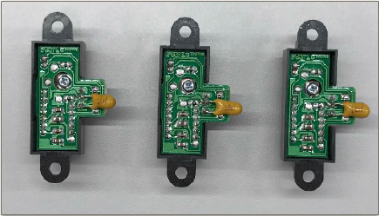

Answer: The 10uF decoupling capacitor helps in stabilizing the voltage reading and decrease noise from the sensor readings. This is directly connected to the sensor power supply, and isolates noises which pass through it, thereby reducing the effect of noise on the sensor’s readings.

1. Section 6.2. Which port pins is ADC Ch12, 16 and 17 inputs mapped to? Which PxSELx and what settings are required to configure the pins to ADC function?

Answer:

ADC Channels –

Channel 12 -> Port 4 pin 1

Channel 16 -> Port 9 pin 1

Channel 17 -> Port 9 pin 0

PSELx settings –

P9->SEL1 |= 0x03;

P9->SEL0 |= 0x03;

P4->SEL1 |= 0x02;

P4->SEL0 |= 0x02;

1. Section 6.2. With respect to the ADC on MSP432, what are the two stages involved in every Analog to Digital Conversion of an Analog signal?

Answer: The ADC on the MSP432 is a 14-bit SAR. The two stages are the sample and hold stage, and then the actual conversion.

Sample and hold – Samples the input voltage

ADC conversion step – Digitization of the analog signal

1. Section 6.3. What does the function LPF_Calc() does? What are the initial values of the buffer associated with LPF_Calc()? Why do we need this function?

Answer: The LPF_Calc() function calculates the ADC value by implementing a running average algorithm for digitalization. New data is read by the sensor, added to the sum, and old value removed from the sum. The average is then computed. This creates a window of size S, which is given in the Lab4_ADCmain.c file’s main function. S readings from the sensor will be scanned and the output is a filtered, average reading of the sensor.

The initial values of the buffer associated with LPF_Calc() is a 14-bit value obtained by reading the sensors after a BUSY period as defined in the ADC_ln17_12_16 function.

This function is very important as a filter is integral to a sensor. This is to prevent inaccuracy from sudden noises. This helps get more accurate values from the sensor.

1. Section 6.3. Describe the algorithm you used to estimate the actual distance based on the IR Sensor value.

Answer:

Step 1 is to collect the data from the sensor. First, place the object at different distances away from the robot. Then, collect data every 2000 samples by placing a break point in the while loop. We must pay close attention to the nr, nc and nl values. Obtain the ADC values and input to the spreadsheet.

Step 2 is to use a software to linearlise the curve. Plot a graph of distance vs 1/a, which will be more or less linear. Find the best fit line of this graph.

Step 3 is implementing the character equation in the IRDistance.c function. Copy the equation into the conversion functions rightConvert, centerConvert and leftConvert in IRDistance.c. Add code to make sure that the correct distance value is returned. Repeat and test for errors if necessary (wrong values).

1. Section 7.2. Which timer capture input (Timer and Channel number) does P10.4 and P10.5 correspond to?

Answer: P10.4 – Timer A3 channel 0.

P8.2 – Timer A3 channel 2.

1. Section 7.2. Which edge (falling, rising, both) is the timer input capture configured to trigger on? What happens when a capture event occurs?

Answer: It triggers on the rising edge. At the rising edge, the timer value is saved into the corresponding CCR register channels. According to lab 4, this is done in the timer interrupt handlers TA3_0_IRQHandler and TA3_N_IRQHandler respectively. These get called when interrupts from timer A3 in the channels occur.

When the capture events occur, two user tasks PeriodMeasure0 and PeriodMeasure2 are executed. These calculate the period between the edges which is also known as the two ticks. From this, we can calculate the rotation speed of the motors and make adjustments wherever required.

1. Section 7.2. Why is the calculated value of pulse duration, derived from the timer capture values, not a constant value but seemed to keep changing?

Answer: When the light collector of the tachometer receives light from the light emitter, it generates a voltage depending on the amount of light it receives. This is converted and digitalized to 0 or 1 to generate the square waves to be used in our application.

There might be a fluctuation in readings due to the conversion from analog to digital values, since a continuous variable is sampled at discrete values. Also, considering that it’s sampled through the slit, and sometimes the sampling may be done when the light has gone halfway, or just a little more or a little less. These minor differences may cause a difference in the readings, which may give a different value when it’s quantized from 0 to 1. This causes a change in pulse duration due to the time capture.